

AP® Physics C
1982 Free Response Questions

The materials included in these files are intended for use by AP teachers for course and exam preparation in the classroom; permission for any other use must be sought from the Advanced Placement Program®. Teachers may reproduce them, in whole or in part, in limited quantities, for face-to-face teaching purposes but may not mass distribute the materials, electronically or otherwise. These materials and any copies made of them may not be resold, and the copyright notices must be retained as they appear here. This permission does not apply to any third-party copyrights contained herein.

These materials were produced by Educational Testing Service® (ETS®), which develops and administers the examinations of the Advanced Placement
Program for the College Board. The College Board and Educational Testing Service (ETS) are dedicated to the principle of equal opportunity, and their
programs, services, and employment policies are guided by that principle.

The College Board is a national nonprofit membership association dedicated to preparing, inspiring, and connecting students to college and opportunity.
Founded in 1900, the association is composed of more than 4,200 schools, colleges, universities, and other educational organizations. Each year, the
College Board serves over three million students and their parents, 22,000 high schools, and 3,500 colleges, through major programs and services in
college admission, guidance, assessment, financial aid, enrollment, and teaching and learning. Among its best-known programs are the SAT®, the
PSAT/NMSQT®, and the Advanced Placement Program® (AP®). The College Board is committed to the principles of equity and
excellence, and that commitment is embodied in all of its programs, services, activities, and concerns.

APIEL is a trademark owned by the College Entrance Examination Board. PSAT/NMSQT is a registered trademark jointly owned by the College Entrance Examination Board and the National Merit Scholarship Corporation. Educational Testing Service and ETS are registered trademarks of Educational Testing Service.
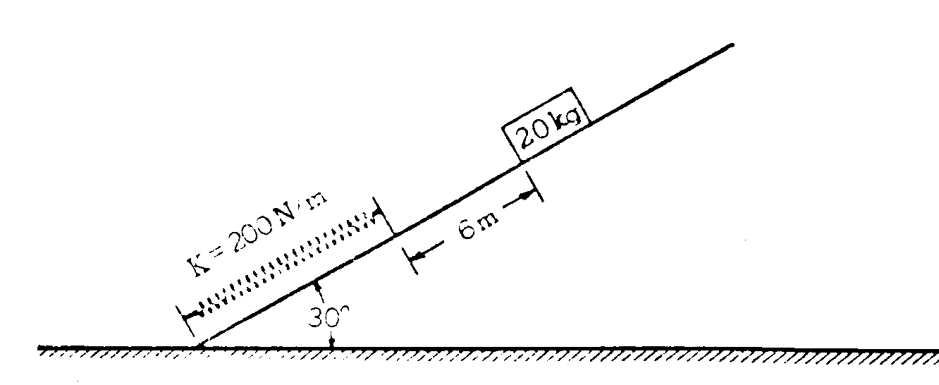
1982M1. A 20 kg mass, released from rest, slides 6 meters down a frictionless plane inclined at an angle of 30º with the horizontal and strikes a spring of spring constant K = 200 newtons/meter as shown in the diagram above. Assume that the spring is ideal, that the mass of the spring is negligible, and that mechanical energy is conserved. Use g = 10 m/s², (sin30º = ½, cos 30º = 0.866)
a. Determine the speed of the block just before it hits the spring.
b. Determine the distance the spring has been compressed when the block comes to rest.
c. Is the speed of the block a maximum at the instant the block strikes the spring? Justify your answer.

1982M2. A car of mass M moves with an initial speed v_{o} on a straight horizontal road. The car is brought to rest by braking in such a way that the speed of the car is given as a function of time t by v = (v_{o}² - Rt/M)^{½}
a. Develop an equation that expresses the time rate of change of kinetic energy.
b. Determine the time it takes to bring the car to a complete stop.
c. Develop an equation for the acceleration of the car as a function of time t.
d. On the axes below, sketch the magnitude of the braking force as a function of time t.
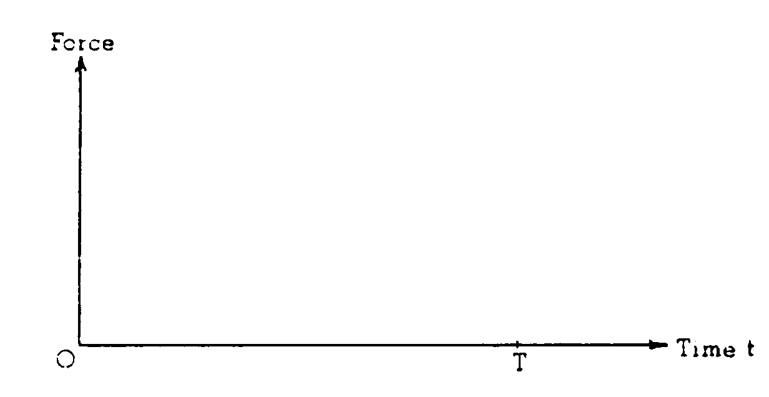
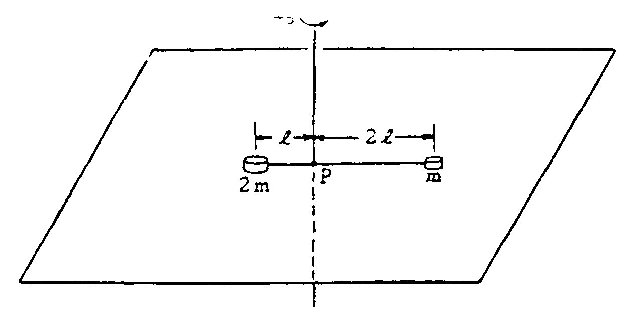
1982M3. A system consists of two small disks, of masses m and 2m, attached to a rod of negligible mass of length 3l as shown above. The rod is free to turn about a vertical axis through point P. The two disks rest on a rough horizontal surface; the coefficient of friction between the disks and the surface is μ. At time t = 0, the rod has an initial counterclockwise angular velocity ω_{o} about P. The system is gradually brought to rest by friction. Develop expressions for the following quantities in terms of μ m, l, g, and ω_{o}
a. The initial angular momentum of the system about the axis through P
b. The frictional torque acting on the system about the axis through P
c. The time T at which the system will come to rest.
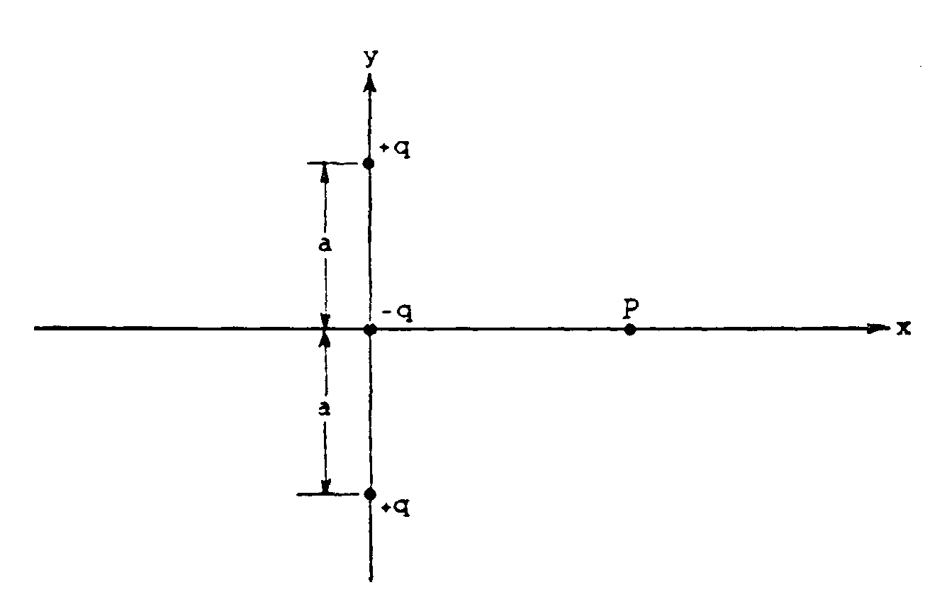
1982E1. Three point charges are arranged on the y-axis as shown above. The charges are +q at (0, a),
-q at (0, 0), and +q at (0, -a). Any other charge or material is infinitely far away.
a. Determine the point(s) on the x-axis where the electric potential due to this system of charges is zero.
b. Determine the x and y components of the electric field at a point P on the x-axis at a distance x from the origin.
c. Using Gauss's law, determine the net electric flux through a spherical surface of radius r = 2a centered at the origin.

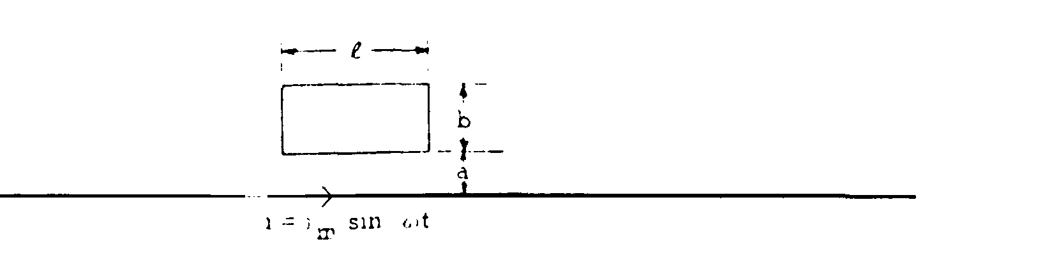
1982E2. As shown above a rectangular loop is located next to a long straight wire carrying a current i = i_{m}sinωt
The wire and the loop are in the plane of the page and fixed in space
a. Using Ampere's law, show that the magnetic c field intensity at a distance r from the wire is
B = μ_{o}I/2πr, with μ_{o} being the permeability of free space.
b. Find the magnetic flux Φ_{B} through the loop at time t.
c. The current i in the long wire is in the direction shown above from t = 0 to t = π/ω.
i. indicate on the diagram above the direction of the resulting current that is induced in the loop at time t = π/ω
ii. Determine the emf that is induced in the loop at time t = π/ω.
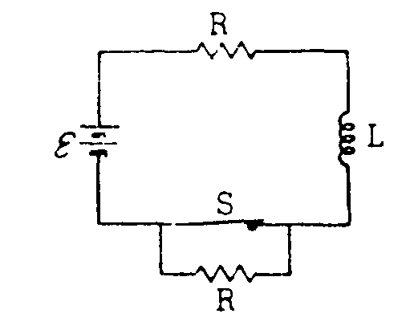
1982E3. When the switch S in the circuit shown above is closed, an inductance L is in series with a resistance R and battery of emf Ε.
a. Determine the current i in the circuit after the switch S has been closed for a very long time.
After being closed for a very long time, the switch S is opened at time t = 0.
b. Determine the current i_{B} in the circuit after the switch has been open for a very long time.
c. On the axes below, sketch a graph of the current as a function of time t for t > O and indicate the values of the currents i_{A} and i_{B} on the vertical axis
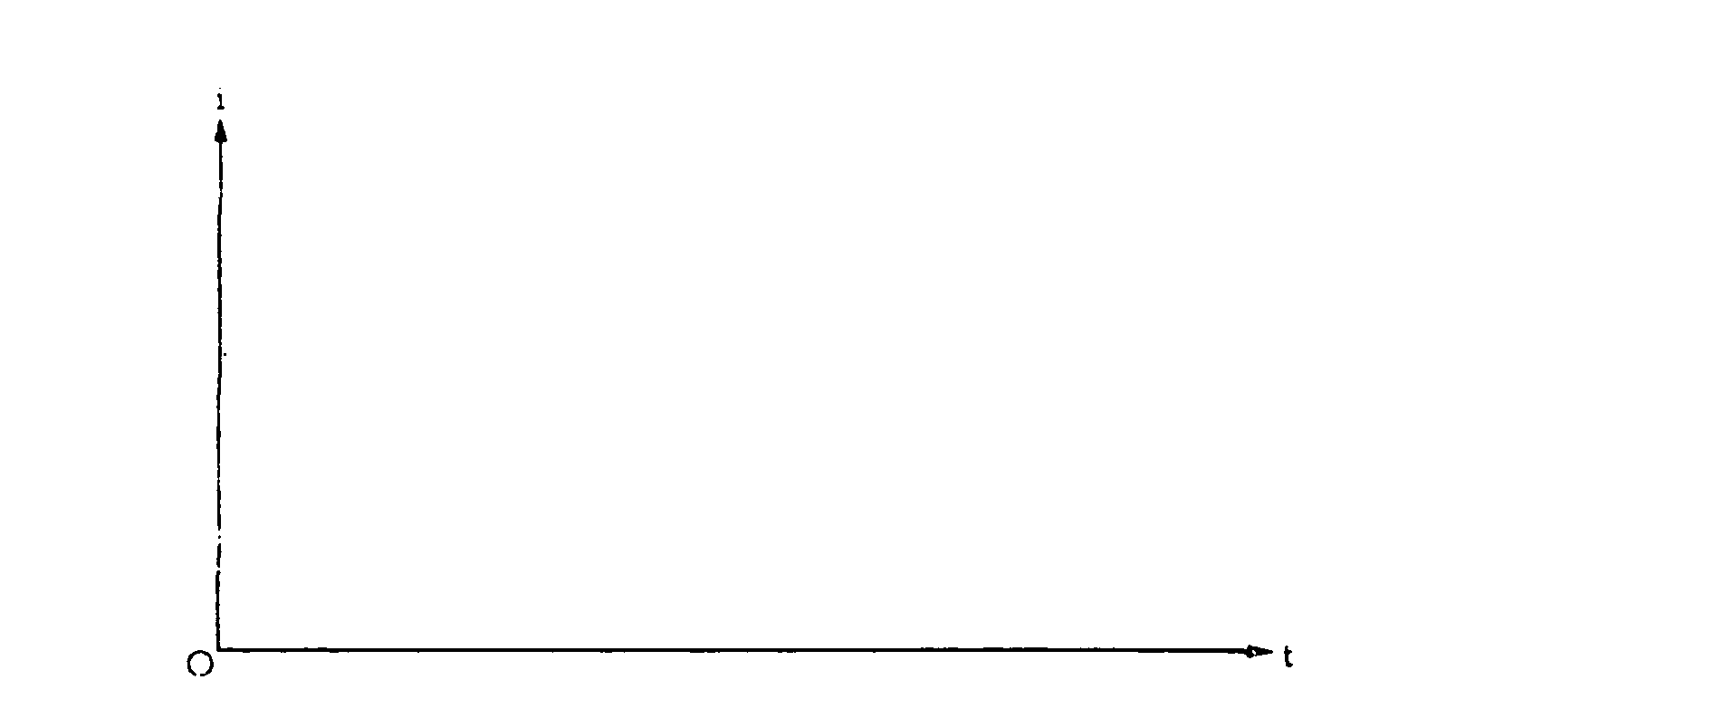
d. By relating potential difference and emf's around the circuit, write thc differential equation that can be used to determine the current as a function of time.
e. Write the equation for the current as a function of time for all time t > 0.

